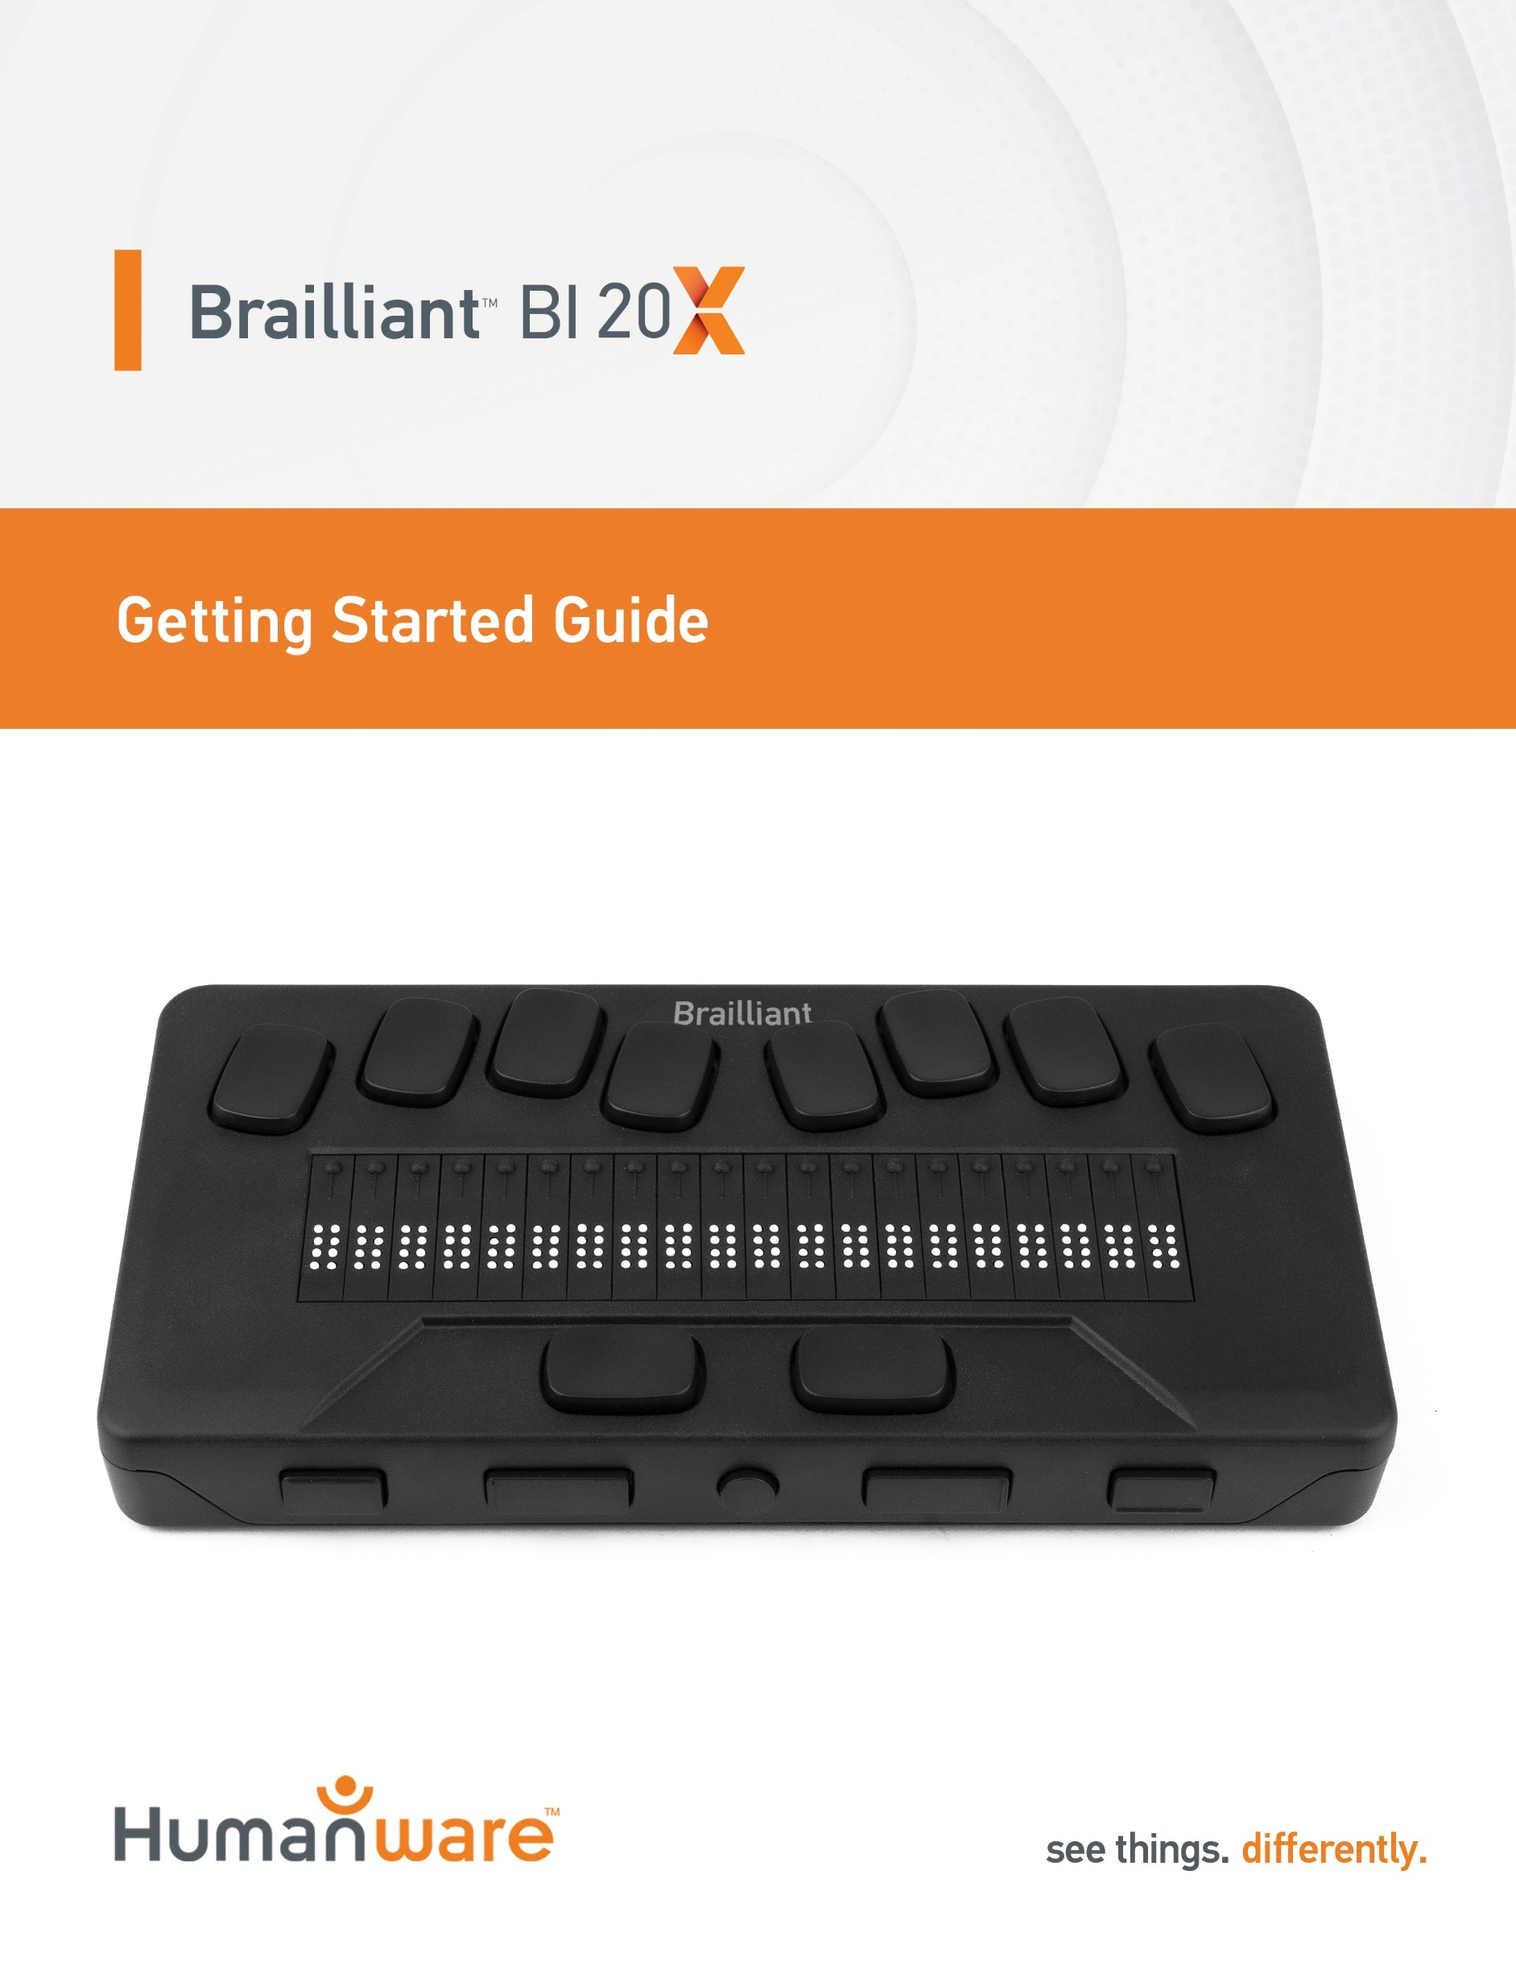

Getting Started Guide

1. Overview

1.1. Front perspective view

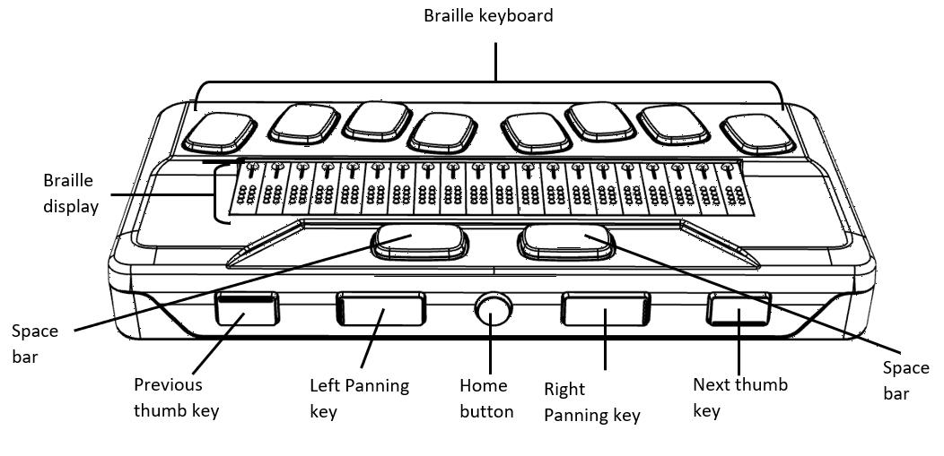

1.2. Left side view
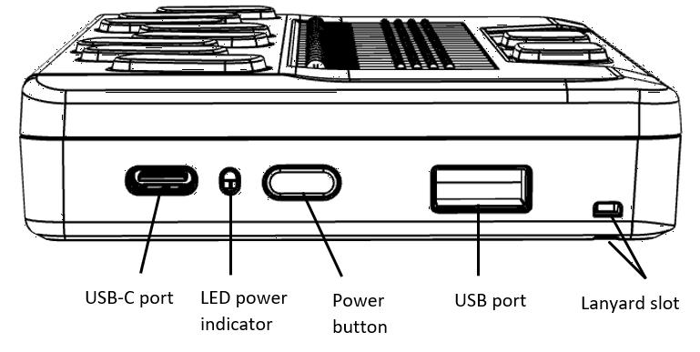

1.3. Right side view
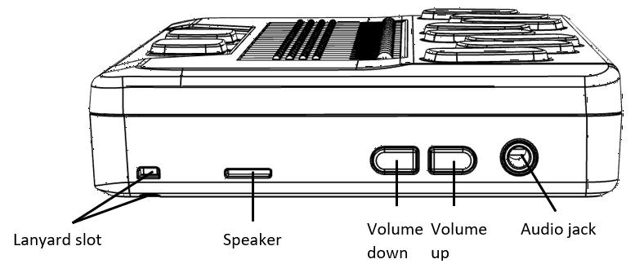

1.4. Rear view
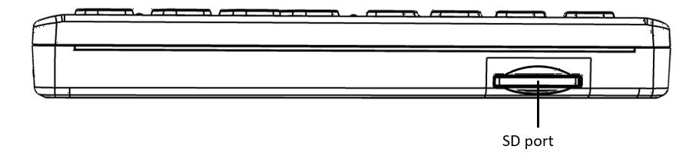

2. Getting Started
Thank you for purchasing the Brailliant™ BI 20X refreshable braille display. This Getting Started Guide provides instructions for charging the device, orientation, powering on and off, navigating menus, panning text, using the Context Menu, and accessing the User Guide. For more information on how to use your Brailliant, please refer to the digital User Guide integrated in your device.

3. In the Box
- Brailliant™ BI 20X braille display
- USB-C to USB-A cable
- USB to AC adapter
- Print Getting Started Guide
- Nylon carrying case
- Braille insert on how to access the user guide

4. Orientation and Description
With the device on a flat surface in front of you, the proper operational orientation is with the braille cells closest to you.

4.1. Top surface
The top surface includes the braille display and the braille keyboard. Beginning with the braille cells (closest to you) and moving away from you are the small round Cursor Routing buttons, located just above the braille cells. You use the Routing buttons to move the braille cursor when reading and editing and to activate items in a menu.
Continuing away from you, on a small rise in the surface is the braille keyboard. The layout of the keys for the braille keyboard is similar to most braille displays, with the traditional six Braille-input keys, a Backspace key (Dot 7), an Enter key (Dot 8), and two Space keys.

4.2. Front Edge
Along the front edge of the device (closest to you) are five controls. The two outermost rectangular buttons are the Previous and Next thumb keys and are used to move between items in a menu.
Moving inward along the front edge, are two more rectangular buttons called the Panning keys. These allow you to move to the previous and next 20-cell section of the text you are reading.
In the center of the front edge is the small, round Home key. Use this key to return to the Main Menu at any time, as well as to exit the braille terminal when in Terminal mode.

4.3. Left Edge
On the left edge of the device, in order from front edge to back, are the following:
- The Lanyard slot
- The USB-A port—used to connect a USB drive or other external USB storage device to the Brailliant.
- The Power button—has a small dot on it for easy recognition.
- A small LED display—shows the status of your device.
- The USB-C connector—used to connect the Brailliant to a host device or the AC adapter.

4.4. Back Edge
On the back edge of the device and to the far left is an SD Card slot. Use an SD card for storing documents and for updating the software and firmware on the device.
4.5. Right Edge
On the right edge, from front to back, are the Lanyard slot, the Speaker, Volume Down and Volume Up buttons, and the Audio jack.

5. Charging the Device
NOTE: Make sure to charge your Brailliant completely prior to use.
Connect the USB-C end of the USB cable to the USB-C port located on the left edge of your Brailliant. Very little effort is required and forcing the connection can damage the cable or the device.
Connect the other end of the USB cable to the power adapter. Then plug the power adapter into a power outlet. The USB connector and power adapter are included with your Brailliant. Use the provided power adapter for optimal recharge.

6. Powering On and Off
If your device is charged, press and hold the Power button on the left edge of the device for approximately 2 seconds to turn on your Brailliant. "Starting" should appear on the braille display with a tactile loading animation that circles during start-up.
A few moments after you boot your device for the first time, you will be welcomed with a language selection menu. Press Enter to open the list of languages, select one and press Enter to close the list.
Another item available is “Start in terminal”. If you prefer the Brailliant to startup in terminal mode each time from a complete shutdown, you can activate this by pressing Enter. Refer to the user settings section for more information on activating or deactivating the start up in terminal.
Close the dialog box once the changes are completed.
After a few seconds, loading is complete. The “terminal” application is shown as selected on the braille display. Your Brailliant is now ready for use.
If however you turned on start in terminal, the Brailliant will prompt “USB connection”.
To turn the device off, press and hold the Power button for 2 seconds.

7. Navigating Menus
KeySoft Lite is the heart of your Brailliant BI 20X, supporting all applications that are built in your braille display. KeySoft’s main menu can also be customized, which will allow you to hide and unhide applications from the Main menu.
To navigate from item to item in menus, press the Previous (leftmost) and Next (rightmost) thumb keys, located on the front edge of your device. As you press the Previous and Next thumb keys, the menu item changes on the braille display. Each item represents an application or option you can activate.
To activate a menu item, press one of the Cursor Routing keys. You can also press the Enter key (Dot 8) on the braille keyboard to activate a menu item.

8. Panning Text
Often, sentences may exceed the 20 characters displayed on your Brailliant. To continue reading through the end of a sentence or backward towards the start of a sentence, use the Left and Right thumb keys immediately to the left and right of the Home button to pan text.

9. Using the Context Menu
The Context Menu is accessible from almost everywhere in your device. It offers useful contextual functions that are relevant to what you are currently doing on your Brailliant. This is similar to the Context menu on a PC. If you are looking for a specific action or shortcut, chances are you can find it in the Context Menu.
To activate the Context Menu, press Space + M (Dots 1, 3, 4). A menu opens with a list of actions you can perform at that moment. Scroll through this menu until you find what you are looking for, then press Enter (Dot 8) or a Cursor Routing button.

10. Accessing the Built-in User Guide
Activate the built-in User Guide item from the Main menu. There you find the complete user guide along with a command reference. This is where to find the most up-to-date information, as well as other resources to help you make the most of your Brailliant BI 20X.
You can also download the user guide from the support page of http://www.humanware.com.

11. Brailliant Installation and connectivity

11.1. Interface Ports
Depending on the operating system, you can connect Brailliant via various interfaces to your PC. Use the USB port to communicate with PCs or Notebooks or the built-in Bluetooth interface for your mobile devices.

USB Port
USB connectivity is supported by Windows computers (32 and 64 bits).
Plug the USB Connector into your PC. Plug the small USB-C Plug at the other end of the USB cable into the Brailliant USB-C port. This is the small oval socket on the left side.

11.2. Connecting to a PC or Notebook
Brailliant can be used as a Braille display with popular PC screen readers such as JAWS, NVDA, SuperNova etc. The PC or Notebook must provide either USB or a wireless Bluetooth interface (built-in or by using a USB Bluetooth dongle).
JAWS
JAW 2020 includes the necessary drivers to detect the Brailliant. If however, you are using JAWS 2018 or 2019 an installation driver is required. This can be obtained by visiting the support section at www.humanware.com
Other Screen Readers
Brailliant is compatible with other screen readers. Please consult our website's support page for additional information: http://www.humanware.com
To connect in Terminal mode, make sure you have a Windows®, iOS®, or Mac® device with a screen reader running.
To connect via USB:
- Press Space + Dots 1-2-3-4-5-6 or the Home button to enter the Main menu.
- Go to Terminal by pressing ‘t’ or by using the Previous and Next thumb keys.
- Press Enter or a cursor routing key.
- Connect the Brailliant to a Windows or Mac computer with the USB-C cable.
- Select Connected devices (first item in the Terminal menu).
- Press Enter.
- Select USB connection.
- Press Enter.
- Wait for the connection to be established.
If the connection is successful, the content of your host device is shown on the braille display.
The Brailliant is now also available as an external keyboard to type on the host device.
Connection via Bluetooth
To pair a new device in Bluetooth:
- Press Space + Dots 1-2-3-4-5-6 or the Home button to enter the Main menu.
- Go to Terminal by pressing ‘t’ or by using the Previous and Next thumb keys.
- Press Enter or a cursor routing key.
- Click Add Bluetooth device.
If Bluetooth is Off, it is automatically activated.
Note that at any time, you can press and hold the Enter key for 5 seconds to set the device in a 5-minute discoverable mode.
- Read instructions on the display.
- The focus returns to connected devices.
- From the host device, initiate the Bluetooth pairing.
- Once the connection is complete, press the Previous thumb key on the Brailliant until you reach Connected devices.
- Press Enter or a cursor routing key.
The connected device appears in the list.
- Press Enter or a cursor routing key.
- Wait for the connection to be established.
If the connection is successful, the content of your host device is shown on the braille display.
The Brailliant is now also available as an external keyboard to type on the host device.

12. Manufacturer Warranty
This device is a high-quality product, built and packaged with care. All units and components are guaranteed against any operational defects for 2 years for all countries.
Warranty covers all parts (except battery) and labor. If any defect should occur, please contact your local distributor or the manufacturer technical assistance line.
Note: Warranty terms may periodically change, please consult our website for the latest information.
North America: In addition to the warranty, you can also purchase a Brailliant care plan to prolong coverage for one year and also benefit from the cleaning service and a loan program. Please refer to our web site: http://www.humanware.com/
Or contact us by E-mail at us.info@humanware.com or call 1(800) 722-3393

12.1. Conditions and Limitations:
No replacement or repair covered by the warranty will be carried out unless the unit is accompanied by a copy of the original bill of purchase. Please retain your original. If the unit has to be returned, please use the original packaging. This warranty applies to all cases where the damage is not a result of improper use, mistreatment, negligence or acts of God.

13. Specifications
- Power requirement: +5VDC@1.5A
- Battery: Li-Ion 3.7V nominal, 2000 mAh
- Operating temperature range: +5 ~ +45 degrees Celsius
- Battery charging temperature range: +5 ~ +35 degrees Celsius
- Storage temperature: -20 ~ +65 degrees Celsius
- Operating humidity: 5% ~ 95% (non-condensing)
- Storage humidity: 5% ~ 95% (non-condensing)

14. Warnings

Battery Safety Precautions:
CAUTION:
- Risk of explosion if battery is replaced by an incorrect type.
- Dispose of used batteries according to the instructions below.
- Do not disassemble or modify the battery.
- Use only the specified HumanWare charger.
- There is a risk of overheating, fire or explosion if the battery is put in a fire, heated, subjected to impact, put in contact with water, or if its terminals are shorted.
- Do not attempt to charge or use the battery outside of the unit.

Disposal Instructions:
At the end of the Brailliant’s operational lifetime, its internal components must be disposed in compliance with local authorities.
The Brailliant BI 20X contains no hazardous materials. For disposal, follow local governing ordinances or hospital procedure.

SD Card Opening:
Do not insert foreign object except SDHC cards.

FCC Warning
This device complies with part 15 of the FCC Rules. Operation is subject to the following two conditions: (1) This device may not cause harmful interference, and (2) this device must accept any interference received, including interference that may cause undesired operation.
Changes or modifications not expressly approved by the party responsible for compliance could void the user’s authority to operate the equipment.

Note: This equipment has been tested and found to comply with the limits for a Class B digital device, pursuant to part 15 of the FCC Rules. These limits are designed to provide reasonable protection against harmful interference in a residential installation. This equipment generates, uses and can radiate radio frequency energy and, if not installed and used in accordance with the instructions, may cause harmful interference to radio communications. However, there is no guarantee that interference will not occur in a particular installation. If this equipment does cause harmful interference to radio or television reception, which can be determined by turning the equipment off and on, the user is encouraged to try to correct the interference by one or more of the following measures:
- Reorient or relocate the receiving antenna.
- Increase the separation between the equipment and receiver.
- Connect the equipment into an outlet on a circuit different from that to which the receiver is connected.
- Consult the dealer or an experienced radio/TV technician for help.

Industry Canada statements
This device complies with Industry Canada licence-exempt RSS standard(s). Operation is subject to the following two conditions:
(1) this device may not cause interference, and (2) this device must accept any interference, including interference that may cause undesired operation of the device.
Le présent appareil est conforme aux CNR d’Industrie Canada applicables aux appareils radio exempts de licence. L’exploitation est autorisée aux deux conditions suivantes : (1) l’appareil ne doit pas produire de brouillage, et (2) l’utilisateur de l’appareil doit accepter tout brouillage radioélectrique subi, même si le brouillage est susceptible d’en compromettre le fonctionnement.
CAN ICES-3 (B)/NMB-3(B)



ACCD-0257
Rev 02

